**Day 5 Assignment - 08/12/2023 - Vamsi Viswanadham**

Worked on the below concepts.

* Using an Equi Join
* Using a Self-Join
* Joins with groupby, having by, grouping sets
* Querying Data by Using Subqueries
* Using the EXISTS, ANY, ALL Keywords
* Using Nested Subqueries
* Using Correlated Subqueries

Here is the screenshot of the work.

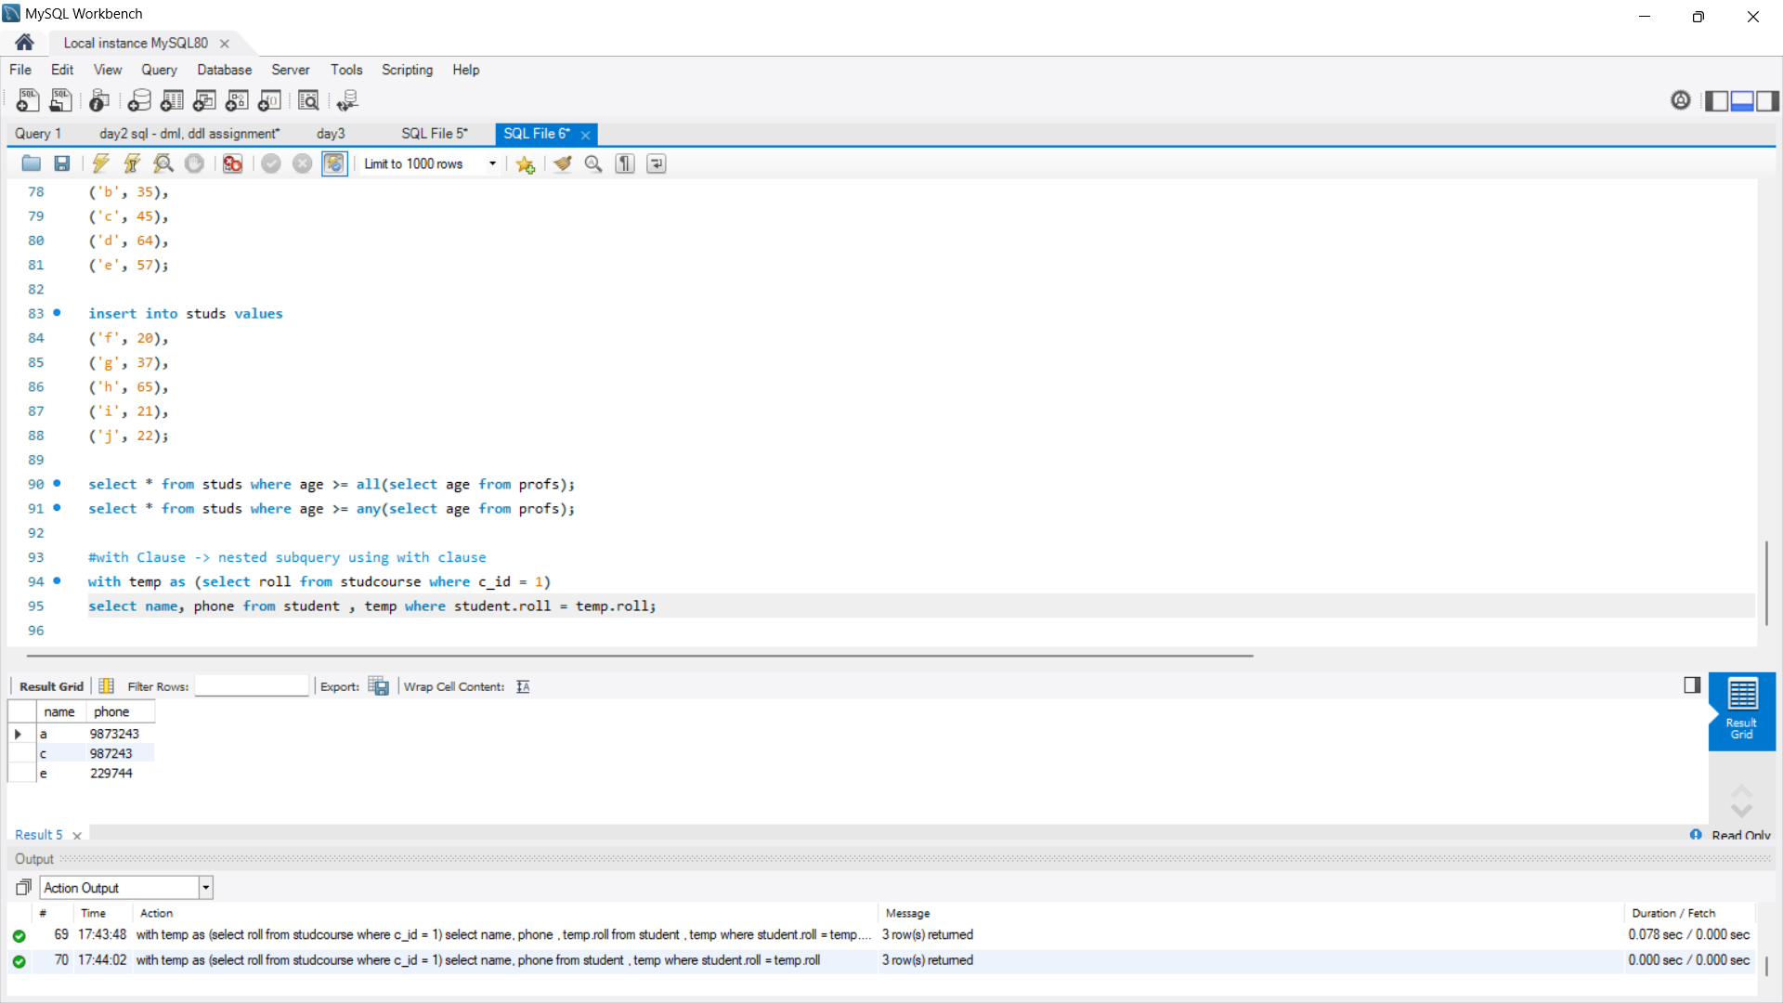

Here is a [SQL file](https://drive.google.com/file/d/1ZHz5QRpGsw23_oTRUxh9jib9pvKO5dZ3/view?usp=sharing) of the work.